Exp.No-17
17.Perform Edge Detection using Sobel Matrix along X-axis

Aim:
To detect the edges of an image along the X-axis using the Sobel operator.
Procedure:
- Start the program.
- Import the OpenCV library.
- Read the input image (puppy.jpg).
- Convert the image into grayscale.
- Apply the Sobel operator along the X-axis.
- Display the original and edge-detected images.
- Save the output image.
- Stop the program.
Program:
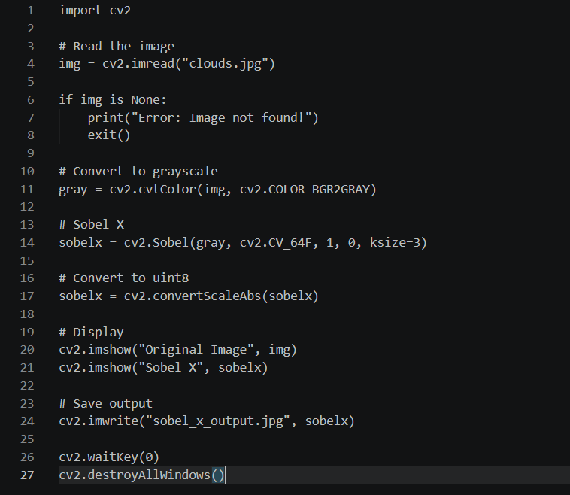

Input:


Output:
Result:
The edges along the X-axis were successfully detected using the Sobel operator.

